**4-21.** Two of the connections in your representations web are pattern → table and pattern → rule. Practice these connections as you answer the questions below.

* 1. On graph paper, draw Figure 0 and Figure 4 for the pattern at below.

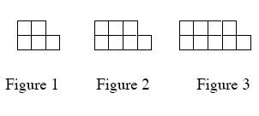

* 1. Represent the number of tiles in each figure with a table.
  2. Represent the number of tiles in each figure with an algebraic rule.

**4-22.** For the rule *y* = *x*2 − 4, calculate the *y-*values that complete the table below. Plot the points and connect them on a complete graph on graph paper. What does your graph look like?

|  |  |  |  |  |  |  |  |
| --- | --- | --- | --- | --- | --- | --- | --- |
| IN (*x*) | −3 | −2 | −1 | 0 | 1 | 2 | 3 |
| OUT (*y*) |  |  |  |  |  |  |  |

**4-23.** For each of the equations below, solve for *x*. Show all work and check your solution.

* 1. −2 + 2*x* = −*x +*2 + *x*
  2. 2 − 3*x* = *x +*2

**4-24.** The length of a rectangle is five centimeters more than twice its width. The perimeter is 100 centimeters. Use Guess and Check to find out how long and how wide the rectangle is. 

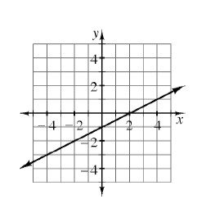**4-25.** Another one of the connections in your representations web is graph → table. In Chapters 1 through 3, you developed tools to find a table from a graph. Consider this connection as you complete the table below based on the graph below right

|  |  |  |  |  |  |  |  |
| --- | --- | --- | --- | --- | --- | --- | --- |
| IN (*x*) | −3 | −2 | −1 | 0 | 1 | 2 | 3 |
| OUT (*y*) |  |  |  |  |  |  |  |