[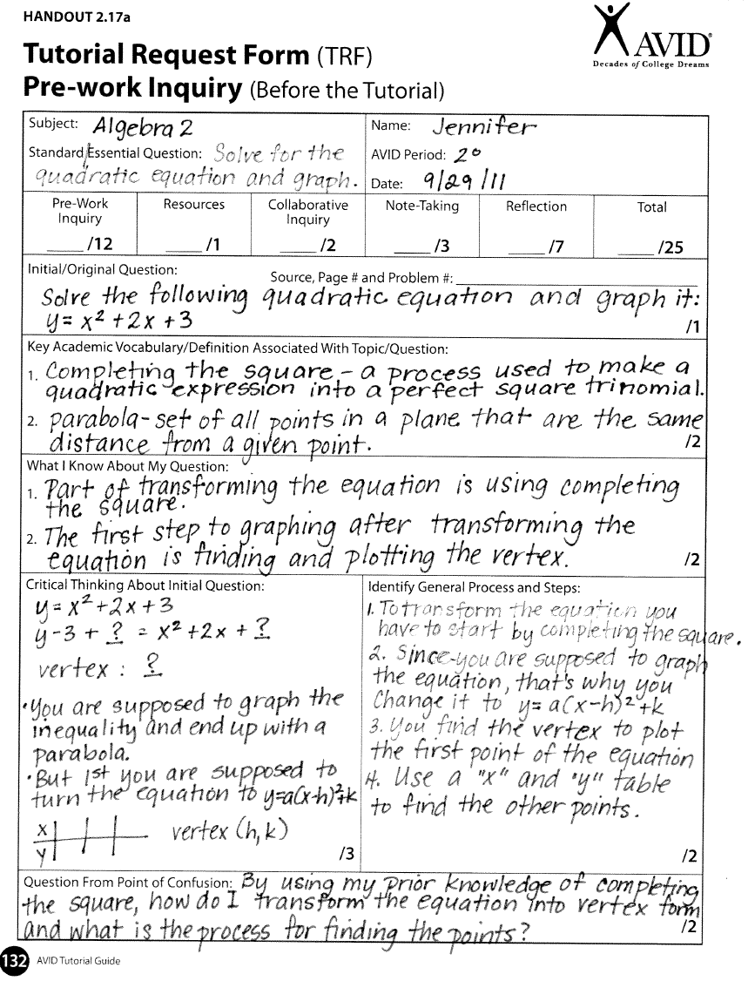](https://sites.google.com/a/csisd.org/avid---college-station-high-school/trf-examples/Alg%20TRF%20Ex.png?attredirects=0)

SAMPLE

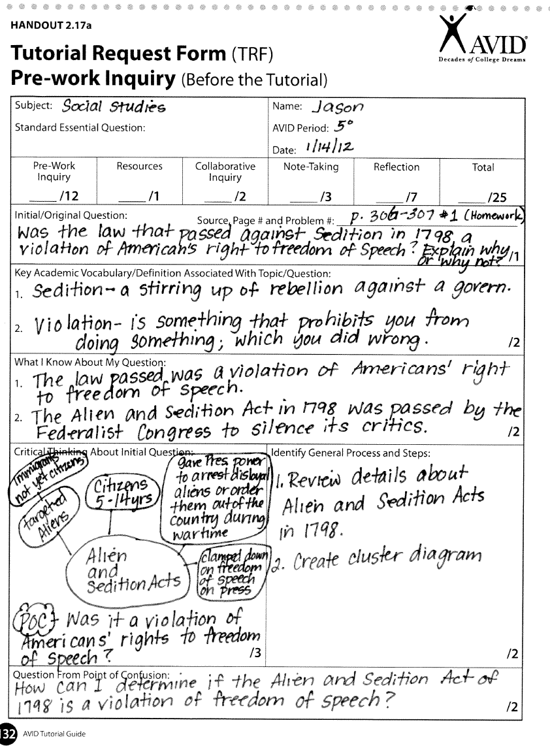

SAMPLE