**4-13.** Write the equation represented in the equation mat below.  [(Html5)](http://www.cpm.org/students/homework/AC_Problems/AC_Ch4_Answers/ac_ch4/AC_4_13m.html)    
  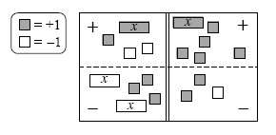

* 1. Simplify as much as possible and then solve for *x*.
  2. Check your solution.

**4-14.** Simplify each of the following equations and solve for *x*. Show all work and check your solution

* 1. 7 − 3*x* = − *x* + 1
  2. 2 3*x* = − (*x*+ 6)

**4-15.** Leala can write a 500-word essay in an hour. If she writes an essay in 10 minutes, approximately how many words do you think the essay contains**4-16.** Copy and complete the table below

|  |  |  |  |  |  |  |  |  |  |
| --- | --- | --- | --- | --- | --- | --- | --- | --- | --- |
| IN (*x*) | 2 | 10 | 6 | 7 | −3 |  | −10 | 1000 | *x* |
| OUT (*y*) | 9 | 25 | 17 |  |  | 15 |  |  |  |

* 1. Explain in words what is done to the input value (*x*) to produce the output value (*y*).
  2. Write the rule you described in part (a) with algebraic symbols.

**4-17.** When Susan’s brother went to college, she and her two sisters evenly divided his belongings. Among his possessions were 3 posters, 216 books, and 24 CDs. How were these items divided? **Tools**